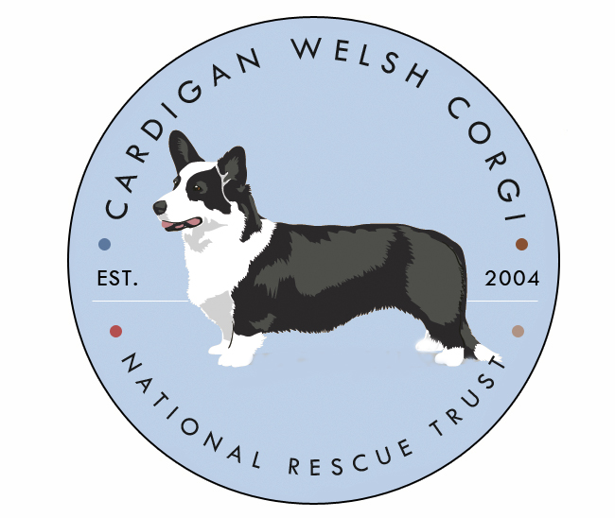

Foster Home Application

Thank you for your interest is becoming a foster home for the Cardigan Welsh Corgi National Rescue Trust. Please complete the following form and submit it to the Regional Coordinator for your state listed at the end of the application.

Name:
Address:
Phone Number:
Email:

What is your experience with Cardigans?

Do you, or have you in the past, volunteered for any rescue organizations?

Do you have other animals at this time? Type, Ages, Number, intact or altered?

How many people are currently in your household, including children and their ages?

Does anyone in your household have allergies to dogs?

What is your household activity like?

Is anyone home during the day?

Do you own or rent? If a renter, does your lease allow dogs?

Describe your home environment. Do you live in an urban or country setting?

Are you able to drive to pick up or transport a dog? If so, what distance are you willing to go?

Are you willing to foster and/or temporarily keep a dog if necessary?

What type of dog would you be willing to foster (ie. Seniors, dogs with medical issues, etc)?

Is your yard fenced? If not, how do you exercise current pets or plan to exercise any future fosters?

Are you able to separate a foster in a quiet space to acclimate if needed?

Where do/would you keep any dog during the day? At night?

References

Please list (2) references, one being your vet:
- Name:
Address:
Phone#:
Relationship:

- Name:
Address:
Phone:
Relationship:

